

TEAM XTRAX FUNDRAISING PACK

Welcome to Team Xtrax

1 Welcome to Team Xtrax

2 How Xtrax makes a difference for young people

3 How your fundraising helps

4 Online fundraising

5 Making a donation

6 Other ways to fundraise

7 Spreading the word

8 Other ways we can help

9 Thank you !



“Life can can be tough for young people growing up in and around Hastings.

Xtrax works to give them a helping hand…

Every penny people raise goes towards supporting the lives of some of the most vulnerable people in our society.”

**Thank you for joining Team Xtrax and**

**supporting us with your fundraising.**

**Together we can make a lasting difference**

**For vulnerable young people in Hastings**

**& Rother.**

The following pages will give you lots of tips,

Ideas and advice on how t make the most of

your fundraising. Every pound you, your

friends, colleagues and family raise for Xtrax

will make a huge difference to a young

person’s future.

Why not join our community of fundraisers on

[Facebook](http://www.facebook.com/XtraxHastings) and follow us on [Twitter](https://twitter.com/XtraxYPC)?

We hope you enjoy your experiences of fund-

raising for Xtrax. If you need any information

or further support, don’t hesitate to call us on

01424-722524 or email us at [info@xtrax.org](mailto:info@xtrax.org)

1 Welcome to Team Xtrax

TEAM XTRAX FUNDRAISING PACK



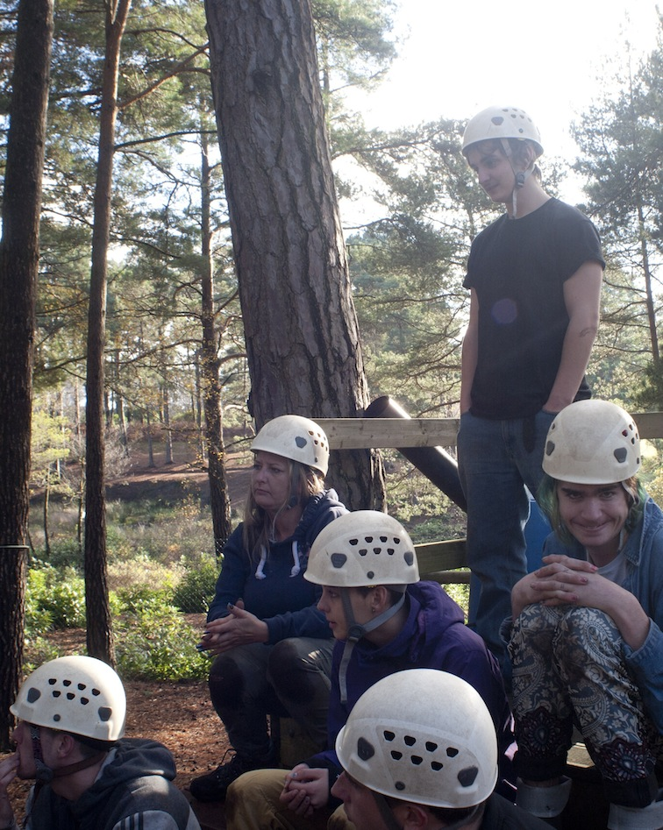

“Xtrax’s lifeline Drop-in Centre has supported thousands of vulnerable young people aged 16-24 since first opening in 1994…

It’s not only a great place for young people to meet and socialise but also get any help they might need in dealing with life’s troubles…”

2 How Xtrax makes a difference

**Jenny’s Story**

“At 16, I was homeless, had no education, and

my mood was incredibly low. I self-harmed and

my self-worth was at rock bottom.

Today, I’m a mother, married, and a university

graduate, I struggle to recognise who I was

back then.

Xtrax got me housed, gave me training oppor-

tunities and, most of all, gave me self-belief.

The staff were so friendly and welcoming, I

could get a square meal at the Drop-in Centre,

and gradually they helped me get into College

and start rebuilding my life.

Nowadays I’m helping others who find them-

selves at a low ebb, working as a support

worker at a Centre in St.Leonards providing

help and inspiration for people who live on

society’s margins.

For along time I never thought I’d work at all –

Now I can’t imagine doing anything else”.

TEAM XTRAX FUNDRAISING PACK

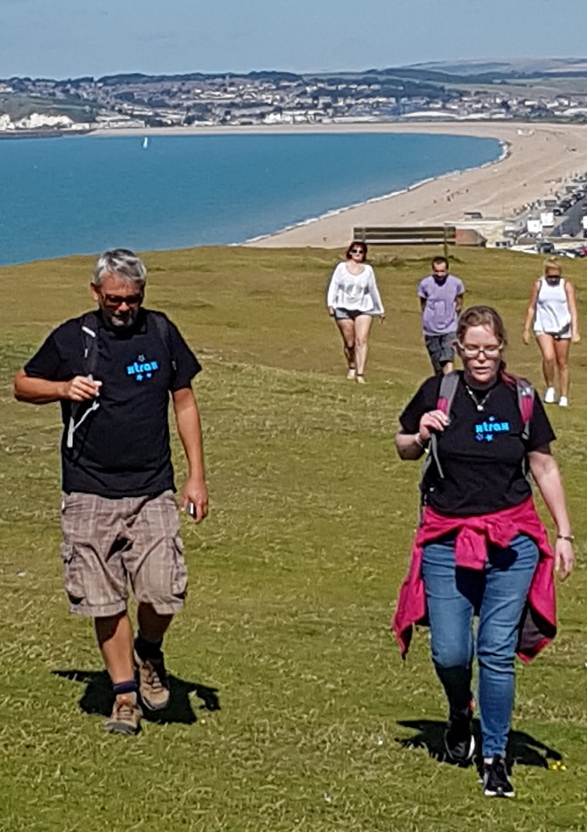

Xtrax supports young people in so many ways…

 A meal at our Young People’s Centre can sometimes be the only hot food they’ll have in a day

 We help the homeless find rooves over their heads and live independently…

 We support young people to overcome mental health problems like anxiety, depression and self-harming…

 And we work with them to succeed through training, education and employment.













**Every pound you raise or donate to Xtrax will**

**make a difference to vulnerable young people**

**in Hastings and Rother, so please set your**

**target high!**

£10 per month (£120) could give over 150

homeless people a hot meal

£20 per month would keep Xtrax’s Young

People’s Centre lit and warm for a whole

month

£100 would pay for 264 square meals for

young people living in poverty

£500 would pay for new play equipment for

our Centre’s Kids Play Zone

£1000 would pay for the books and equipment

for five young people to go to College

£5000 would pay for a minibus to take young

people on excursions of a lifetime

TEAM XTRAX FUNDRAISING PACK

3 How your fundraising helps



Online fundraising is a great way for UK taxpayers to add 25% to every penny they want to donate with a simple click of a button.

Justgiving do charge a small fee (5%) for their services, but with GiftAid added it means Xtrax receives £11:74 for every £10 you raise online!



Online sponsorship saves time as you don’t have to collect donations.

However, if you’d prefer to use a sponsorship form to place in shops and other locations, a pdf of our sponsorship form can be downloaded on our website [here.](http://www.xtrax.org/fundraising)

Please make any cheques from the funds you raise payable to Xtrax and send it to our Centre at 23, Priory Street, Hastings TN34 1EA

**5**

**4**

**3**

**2**

**1**

**The simplest way to ask your friends, family**

**and colleagues to sponsor you is to set up**

**an online fundraising page.**

**Here’s how to do it….**

Go to our approved fundraising website [JustGiving.](http://www.Justgiving.com/xtrax)

Select Xtrax as your chosen charity.

Follow the instructions to set up your page.

Choose your fundraising target, page title and team

members, if you have them. Remember, the. higher

your target is, the more young people we can help.

Tell people why you are fundraising for Xtrax and

how their donation can make a difference.

Once your page is set up, email the link to your

friends, family and colleagues. Don’t forget to

link it to your Facebook page and tweet about it.

It’s a good idea to ask those who might sponsor

you with a larger amount first to encourage others

to be just as generous.

TEAM XTRAX FUNDRAISING PACK

4 Online fundraising



Many people find it easier to simply donate some money to support our work than run an event.

Xtrax welcomes any support you can afford – no matter how small.

You can make a one-off donation, or set up a regular donation at any time by visiting our website at [www.xtrax.org](http://www.xtrax.org)



[**Yes, I’d like to make a donation to Xtrax**](https://xtrax.charitycheckout.co.uk/)

**5**

**4**

**3**

**2**

**1**

5 Making a donation

TEAM XTRAX FUNDRAISING PACK

**Regular support, such as a monthly donation,**

**means we can plan ahead, confident that**

**the funds we need** **will be there when we**

**need them.**

**Giving monthly is easy. No hassle.**

**No time-wasting. Just your money getting**

**to where it’s needed – fast.**

**Here’s how to do it….**

Click on the link below and you’ll be taken

directly to the web page to set up a direct

debit.

Choose how much you’d like to give each month, quarter or annually.

If you’re haven’t donated via Charity Checkout before click ‘Next’ and enter your details to set

up an account.

You’ll receive a confirmation email – click on the link and you can start donating!

Remember - if you’re a UK taxpayer, you can make your donation worth 25% more

at no extra cost with GiftAid.

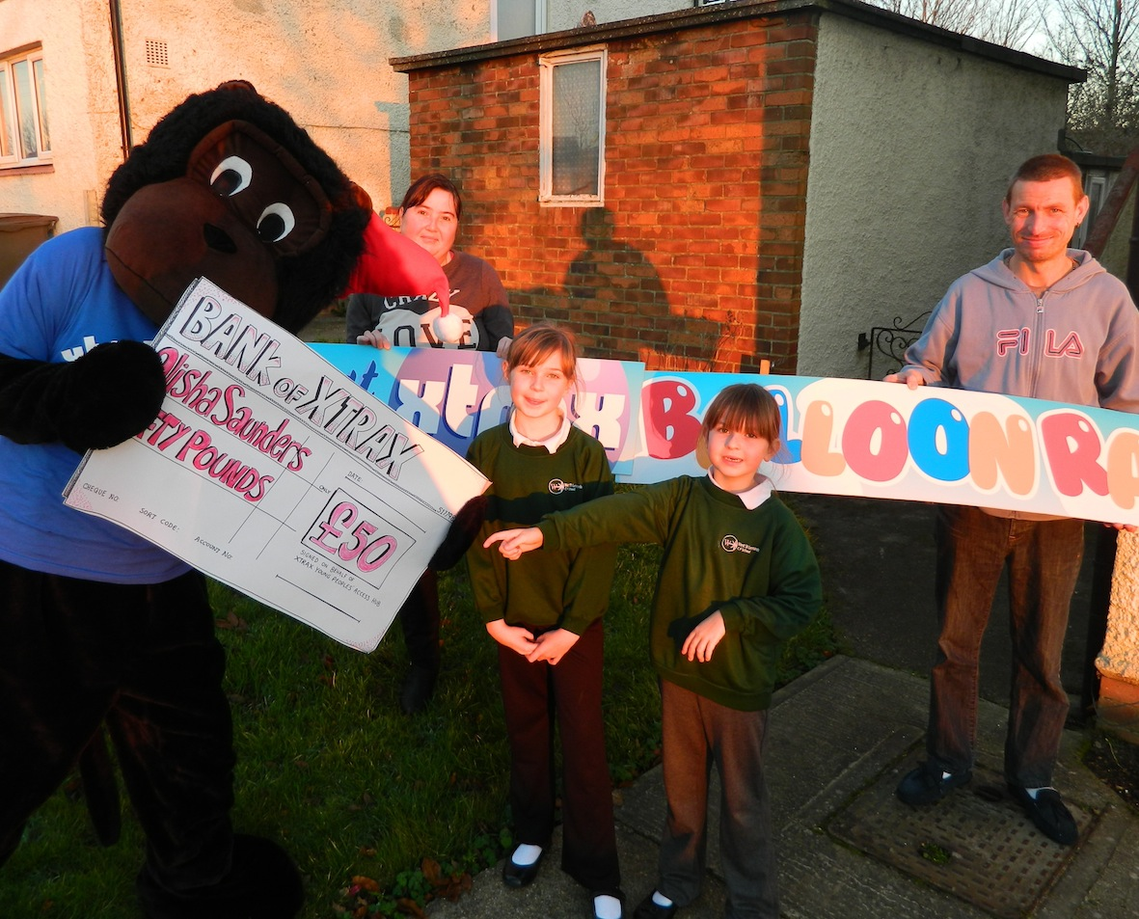

**There are lots more fundraising ideas on JustGiving’s website – you can go directly to their webpage by clicking** [**here.**](http://about.justgiving.com/content/fundraising-ideas?utm_medium=cpc&utm_source=google&utm_campaign=UK-Generic-Fundraising-NonVertical-NA-Exact-Desktop-AlwaysOn&utm_term=fundraising%20ideas)

**And if you want to look at some of the fun activities we’ve done ourselves in the past you can view more details by visiting** [**http://www.xtrax.org/gallery**](http://www.xtrax.org/gallery)

TEAM XTRAX FUNDRAISING PACK











6 Other ways to fundraise

**There are lots of fun ways to reach your**

**fundraising goals. Here are a few ideas to**

**get you started….**

If you like running, why not raise funds for Xtrax

in the Hastings Half Marathon. You can enter

the Run by clicking [**here**](http://www.hastings-half.co.uk/), but don’t forget to

download our sponsorship form or set up your

own fundraising page at JustGiving.

Raise £50 by collecting £1coins in a jar for a

couple of months.

Raise £200 by hosting a quiz night with a raffle.

Charge £5 to enter. Recruit seven teams of six

people and have a raffle on the night to boost

the amount you raise.

Raise £500 by holding a special benefit gig,

tribute band or fancy dress disco. Charge for

tickets and hold a raffle.

Raise £1000 by holding a charity art auction or

auction of pledges. Local businesses are often

willing to support a good cause.

Fundraising top tips:

 Let us know your plans

so we can help spread

the word. Email us at

[info@xtrax.org](mailto:info@xtrax.org)

 Let everyone know using

email, social media,

posters, sponsorship

forms and word of

mouth!

 Make it safe – check out

our legal guidelines on

our website at

[www.xtrax.org/fundraising](http://www.xtrax.org/fundraising)

 …And have fun !



**Get active on Social Media**

 Use photos and videos to tell

people you’re raising money for

Xtrax and why.

 Remember to type

@XtraxHastings in your

Facebook posts or #XtraxYPC

on Twitter.

 Add links to Xtrax’s website

[www.xtrax.org](http://www.xtrax.org)

 Don’t forget you’re raising funds

for a charity supporting

vulnerable young people so

please always make sure what

you’re saying is appropriate and

relevant.

**2**

**1**

TEAM XTRAX FUNDRAISING PACK

**The more you get your message out about your event or activity,**

**the more people will donate, so make sure you publicise what you do.**

**Contact your local newspaper/radio**

 Write a press release including information

about When, Who, What and Why. We’ve

prepared a template for you to try [here.](http://www.xtrax.org/fundraising)

 Send a good photo of you or your activity if

you can – pictures speak a thousand words.

 Always call the Newsdesk to check they’re

received it

7 Spreading the word

Don’t forget to let us know about your fundraising activity or the event you’re planning….

We can always post information about your event on our own website , Facebook page and Twitter account too!

You can email us at : [info@xtrax.org](mailto:info@xtrax.org)

or give us a call on 01424-722524







**We’ve got plenty of flyers, brochures & posters to help spread the word about Xtrax and the work we do…**

**Just let us know and we can deliver them to you…**





If you’ve got any queries, or would like to chat to someone about your fundraising idea, you can ….

Email us at [info@xtrax.org](mailto:info@xtrax.org)

Call us on:

01424-722524

Or drop in to see us at

Xtrax,

23, Priory Street, Hastings,

East Sussex ,

TN34 1EA.

8 Other ways we can help

**Just like you, we want your event to**

**be a success – and depending on**

**your plans there may be other ways**

**we can help.**

Why not order some Xtrax T-shirts or

running vests to show you’re supporting

Team Xtrax? You can download an

order form on our [fundraising page.](http://www.xtrax.org/fundraising)

You can also get collecting buckets and

tins by completing the merchandise order

form, too. Remember, if you’re collecting

on the street, you’ll need permission

from your local authority. Check our legal

guidance here.

Let us know if we may be able to have a

stall at your event, with our great Xtrax

gazebo!

Xtrax’s mascot, Mufti the Monkey may

be able to put in an appearance – great

fun for the kids.

TEAM XTRAX FUNDRAISING PACK





If you’ve got any queries, or would like to chat to someone about your fundraising idea, you can ….

Email us at [info@xtrax.org](mailto:info@xtrax.org)

Call us on:

01424-722524

Or drop in to see us at

Xtrax,

23, Priory Street, Hastings,

East Sussex ,

TN34 1EA.

9 Thank You !

TEAM XTRAX FUNDRAISING PACK

**Xtrax is funded entirely by voluntary donations and the support of Trusts and Foundations across the UK. Here are some of our supporters…**

**Thank you to everyone who’s helped allow Xtrax to support vulnerable young people in Hastings & Rother…**